Article list:

1. <https://medium.com/@theblocknetchannel/the-evolution-of-the-decentralized-exchange-a-brief-history-888ee0ce1803>l

How Exchange work?

1. Centralized

Users do not have access to their private keys.

Driven out of the market by DEX within 5 years.

Pros: with fiat currency

Pros: trade between different blockchains

Pros: higher liquidity

Cons: Private Keys managed by exchange.

1. Decentralized exchanges

what the models of decentralized exchanges offer are in fact the spectrum of technologies with different degrees of centralization.

DEX, four core components of trading were all decentralized (Blocknet version) (from Article1)

1. Capital deposits
2. Order broadcast
3. Order matching
4. The exchange of tokens

History of Cryptocurrency Exchange (from Article1)

1. Bitcoin first brought to the world by Satoshi Nakamoto in 2009,
2. First cryptocurrency exchange (Bitcoinmarket.com) opened in 2010

These exchanges are all centralized.

1. NXT announced their intention to create a decentralized exchange on 3rd January 2014.

NXT (colored coins) ($11m), system of creating assets on pre-existing blockchains.

Problem: Assets could only be traded for the NXT coin

1. In 2014, Counterparty launched their DEX. XCP ($2.7m)

Improvement: XCP tokens were not tied to the BTC balance of any given address.

Problem: Orders were escrowed into the Bitcoin blockchain and confirmation is slow.

1. In end of 2014, Blocknet (Block DX $7.6m). Blocknet Protocol

Enable DApps to be built on the Blocknet Protocol.

1. Various methods of decentralized trading
2. Escrow/Multisig trading method.
3. In 2015. The Atomic Swap system of trading.
4. Generations of DEX
5. 1st Generation DEX — Currency or Chain Dependent: Reliant or built on a specific chain.

2016, Waves ($113m) used the ‘colored coins’ approach.

Coinprism closed in 2018. ‘The unpredictability of transactions fees and confirmation times in the past couple of years have also made it hard to argue bitcoin is a good platform for this’.

Another system IOU/proxy system.

1. 2nd Generation DEX — Contract Dependent: Reliant on smart contracts and Ethereum

--Deposit into smart contract and trade.

The 2nd generation of DEXs relied on Smart contracts built on Ethereum.

‘an asset or currency is transferred into a program “and the program runs this code and at some point it automatically validates a condition and it automatically determines whether the asset should go to one person or back to the other person, or whether it should be immediately refunded to the person who sent it or some combination thereof.’

IDEX ($9.6M)

Limitations:

1. Trading with non-ethereum tokens is not possible.
2. Depositing your funds into a smart contract before trade and it will take time to withdraw them.
3. Smart contract needs to be correctly coded.
4. To complicate things further, on some Ethereum exchanges users must use the Metamask wallet to trade, which can be very confusing to a new trader, and is also a “hot wallet” where your funds are at risk from hackers because the wallet is online.
5. Smart contracts are still slow

Any system that requires the creation of an account, holds your funds online or requires some form of deposit or withdrawal is not decentralized because you are required to relinquish control of your funds to a third party system. This is NOT a non-custodial trading system and thus is not truly decentralized.

Hybrid exchanges (Etherdelta, IDEX), orders books are centralized and account creation may be required.

1. 3rd Generation DEX — Currency Agnostic / Protocol-based / Partially Decentralized Hybrid: Not limited to specific blockchains.

This brings us to the 3rd Generation of DEX’s: those that are built on or use a protocol. So what precisely is a “protocol”? In short, a protocol is an open standard on which developers can build and customize.

**0x protocol**. (ZRX $132m) Designed for the Ethereum network and is based on smart contracts. The 0x protocol acts as a “relayer” so that off-chain orders are relayed to the chain so they can be settled on-chain.

KLyber Network Protocol

Bancor Protocol

Another way is to build on pre-existing blockchains.

2016. ARK SmartBridge ($22m). requires individual Blockchains to directly implement the ARK SmartBridge product into their code.

In 2016. One project on the NXT ecosystem evolved to the Komodo platform ($66m), nodes to back up the Komodo Blockchain every 10 mins and then into BTC chain. This may cause scaling fissues.

1. 4th generation DEX — Currency Agnostic / Fully Decentralized — Protocol Based: Not limited to specific blockchains.

Blocknet Protocol (Block DX):

100% trustless and decentralized. Enables this interoperability through **cross-chain atomic swaps and cross-chain data transfer.**

Three main models for designing an exchange:

1. Order book model

Example: IDEX

Centralized Exchange:

With few currencies

* Coinbase Pro:

Need to know all your information, need to link to your bank account

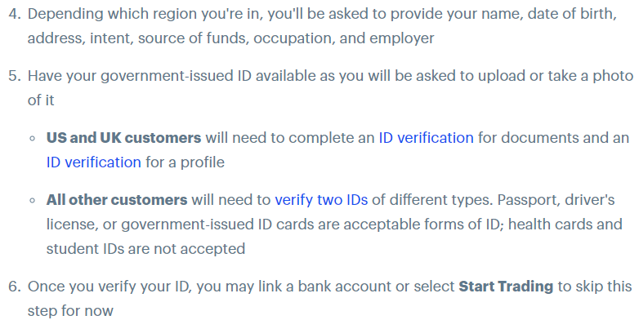

* Kraken:

With more currencies

* Binance
* Bittrex
* Poloniex
* Oceanex (V chain)
* Huobi and OKEX
* BitMEX (high leverage, don’t trade in US)